_{St Columba Middlesbrough}
_{Sung Mass in thanksgiving for}
_{Fr Stephen Cooper`s}
Ruby Jubilee of ordination to the priesthood

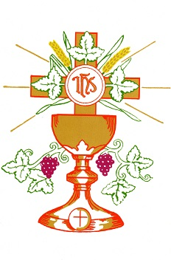
_{Sunday 23rd September 4.00pm}

